**Analysis of Literacy Rate and Growth in India**

Yeshwant Nair

2023

***Abstract***

The growth of any country depends on the quality and skill of its workforce. The quality and skill of any population are directly correlated to the literacy rate of that country. Literacy rate refers to the ability of the percentage of the population to read and write. Since the quality of the workforce in a country depends on the literacy rate, a direct positive relationship exists between the literacy rate and the growth of the country. In the context of India, the literacy rate was around 14% at the time of independence, and as of the 2011 census, it stands at approximately 73%.

**Introduction**

Literacy and development go hand in hand. The benefits of literacy are confined not only at an individual level but also at the community level. According to UNESCO, literacy refers to the “Ability to identify, understand, interpret, create, communicate, compute and use printed and written materials associated with varying contexts. Literacy involves a continuum of learning enabling individuals to achieve their goals, develop their knowledge and potential, and participate fully in their community and wider society.”

In a society, educational attainment and literacy rates are vital indicators, so much so that they are enshrined in the UN SDG 4 goal of ensuring quality education that will be achieved by 2030 by all countries worldwide.

In order to assess the level of development achieved by any country, we need to look into the fundamental pertinent indicators, i.e., the literacy rate and the percentage of contribution of GDP to education. Higher literacy and education levels are directly correlated to improving economic and social conditions. Education is the catalyst for social upliftment in any society, ranging from hygiene, population control, employment, etc.

The literacy rate in India has consistently improved from 18.32% in 1951 to 72.98% in 2011, with female literacy increasing from 8.86% to 64.63% and male literacy increasing from 27.15% to 80.9% in 2011.

**Literature Review:**

Literate societies enable the members of society to interact with each other and, through their interaction, contribute to society's development. One of the primary agenda in the Millenium Development Goals of the United Nations was the attainment of universal primary education among the member states by the year 2015. In India, the Planning Commission of India had targeted the Eleventh Five Year plan to improve the literacy rate to 85% for individuals aged seven and above. The intention behind enhancing the literacy rate is that literacy and educational development are vital variables that affect key demographic indicators such as fertility, mortality, and migration. When looking at the census data, we can see a significant improvement in the proportion of the literate population, which has improved from 65 percent in the 2001 census to 74 percent in the 2011 census. A significant milestone witnessed in the 2011 census was the drop in the number of illiterates by 31,196,847 people.

However, the concept of literates and illiterates is subjected to various variations from census to census. This is evident as the 2011 census considers individuals aged seven and above who can read and write as literate. In contrast, the census before 1991 considered children younger than five years as illiterate. The effective literacy rate is the literacy rate calculated using individuals aged seven and up as the denominator.

Crude Literacy Rate = Number of Literate people x 100 / Total Population

Effective Literacy Rate = Number of Literate persons aged 7 and above x 100 / population aged 7 and above

Prior to the British era, education in India was mainly confined to the Gurukals. These Gurukals were funded by public donations and acted as the earliest form of public school. However, as the British colonial era began, the gurukul system began to decline as the education system espoused by the British gradually began to take over.

Post Independence, we can witness a magnitude shift in literacy, evident from the universal and compulsory education for all children aged 6-14. This was accomplished as a result of the passage of the 86th constitutional amendment act in 2002, which made primary education a fundamental right for children aged 6 to 14. To focus more funds toward the development of education in India, the Finance Act 2004 imposes a 2% education cess on all direct and indirect taxes.

In the 'Augmented Solow' model of Mankiw, Romer, and Weil (1990), education is incorporated into the production function as a form of capital. That is, an increase in the number of literate individuals will directly increase the country's output level per worker. However, this will not affect the growth rate in the long run because, in the long run, all other components will adjust to this new literacy level naturally.

On the other hand, endogenous growth theories are more concerned with the long run. Endogenous growth theories state that an educated populace is more likely to carry out innovations and enhance manufacturing methods, ensuring that more output can be generated with existing input levels. This showcases the possibility of a higher level of education generating higher growth, which is absent in the neoclassical models.

Endogenous models investigate the relationships between humans and produced wealth, whereas Solow theories are more focused on human wealth functioning with a particular technology.

Foster and Rosenzweig (1996) examined India during the Green Revolution; they witnessed that localities where average schooling attainment was highest, witnessed the highest benefits from the introduction of new farming technologies.

Barro (1991) found that school enrolment and adult literacy rates significantly positively impact growth.

According to some, increased educational attainment lowers reproduction rates, which increases the size of the country's capital stock compared to its population size, reducing the burden on natural resources.

Ahluwalia (1976) analysed 62 developing countries and witnessed that increase in the national literacy rate has a significant positive impact on the income share of the poorest 40 percent.

Adult literacy programs will be beneficial if and only if the opportunity cost of spending an hour to enhance literacy is greater than working to ensure that the programs should be scheduled to fit into the individual’s working lives. Moreover, When the unemployment rate among illiterate adults is high, opportunity costs tend to be lower.

**Method:**

Secondary data was collected to analyse the impact of the Literacy rate on the country's growth. The secondary data consisted of India's GDP growth rate data from the World Bank database, which was then converted into decadal form. The literacy rate data is obtained from the official website of the Ministry of Statistics and Programme Implementations. The data for the expenditure on Education as % of GDP is obtained from the Ministry of Human Resource Developments website. The literacy rate and Government expenditure data were available in decadal format therefore it was necessary to convert the annual GDP’s into decadal form.

**Specification of the Mathematical Model:**

In order to better understand the impact of literacy and government expenditure on the growth of the country. the following regression model will be utilised.

The GDP will be taken as the dependent variable, which represents the overall economic growth.

The literacy rate and the Government expenditure on Education as percentage of GDP will be the explanatory variable.

For the purpose of figuring out the significance an OLS regression will be done to figure out the significance of the model.

Y=β1+ β2X1 + β3X2 + u

Where,

Y = GDP growth rate

Β1= Intercept

β2 = Slope of the Yield Curve

β3 = Slope of the Yield Curve

X1 = Literacy rate

X2 = Government expenditure on Education as percentage of GDP

**Analysis:**

The decadal Literacy rate of India is as follows:

|  |  |  |  |  |  |  |  |  |  |
| --- | --- | --- | --- | --- | --- | --- | --- | --- | --- |
| **Year** | **Rural** | | | **Urban** | | | **Combined** | | |
| **Female** | **male** | **Total** | **Female** | **male** | **Total** | **Female** | **male** | **Total** |
| 1951 | 4.87 | 19.02 | 12.1 | 22.33 | 45.6 | 34.59 | 8.86 | 27.15 | 18.32 |
| 1961 | 10.1 | 34.3 | 22.5 | 40.5 | 66 | 54.4 | 15.35 | 40.4 | 28.31 |
| 1971 | 15.5 | 48.6 | 27.9 | 48.8 | 69.8 | 60.2 | 21.97 | 45.96 | 34.45 |
| 1981 | 21.7 | 49.6 | 36 | 56.3 | 76.7 | 67.2 | 29.76 | 56.83 | 43.57 |
| 1991 | 30.17 | 56.96 | 36 | 64.05 | 81.09 | 67.2 | 39.29 | 64.13 | 52.21 |
| 2001 | 46.7 | 71.4 | 59.4 | 73.2 | 86.7 | 80.3 | 53.67 | 75.26 | 64.83 |
| 2011 | 57.93 | 77.15 | 66.77 | 79.11 | 88.76 | 84.11 | 64.63 | 80.88 | 72.98 |

Table 1: Literacy Rate

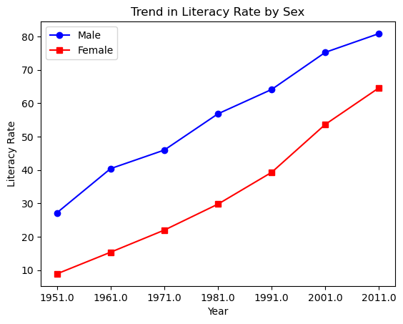

Figure 1. Trend in Literacy Rate by Sex

We can see that India's literacy rate has increased from 18.32% in 1952 to 72.98% in 2011. In 2001, before the Right to Education Act was enforced, India's literacy rate stood at 64.83. After the enactment of RTE in 2009, we can see that the literacy rate increased to 72.98% in the 2011 census. Indicating the success of RTE in increasing India's literacy rate. Many schemes, such as Sarva Shiksha Abhiyan, were also the reason for the higher literacy rate compared to 2001.

The introduction of the Mid-day meal scheme in 1995 was also an important policy measure to increase the country's literacy rate. This is evident from the increase in literacy rate from 52.21% in 1991 to 64.83% in 2001.

These landmark schemes for education, such as the Right to Education, Sarva Shiksha Abhiyan, and the Mid-day Meal schemes, can be seen as pertinent schemes that were responsible for veering India's literacy rate in the right direction as these schemes identified the importance of education to sustain high levels of growth.

Regression shows a causal/functional relationship between the variables considered for analysis. In this context, to check the functional relationship that exists between growth and literacy, and educational development, the following regression is carried out:

Y=α+ β1X1 + β2X2 + u

Where,

Y = GDP growth rate

α = Intercept

β1 = Slope of the Yield Curve

β2 = Slope of the Yield Curve

X1 = Literacy rate

X2 = Government expenditure on Education as percentage of GDP

The results of the regression of the following data are as follows:

|  |  |  |  |
| --- | --- | --- | --- |
| Year | GDP growth rate | Expenditure on Education as % of GDP | Literacy Rate |
| 1951-52 | 2.9 | 0.64 | 18.32 |
| 1960-61 | 3.72 | 1.48 | 28.31 |
| 1970-71 | 4.03 | 2.11 | 34.45 |
| 1980-81 | 3.08 | 2.98 | 43.57 |
| 1990-91 | 5.57 | 3.84 | 52.21 |
| 2000-01 | 5.6 | 4.14 | 64.83 |
| 2011-12 | 6.75 | 3.88 | 72.98 |

Table 2: Dataset

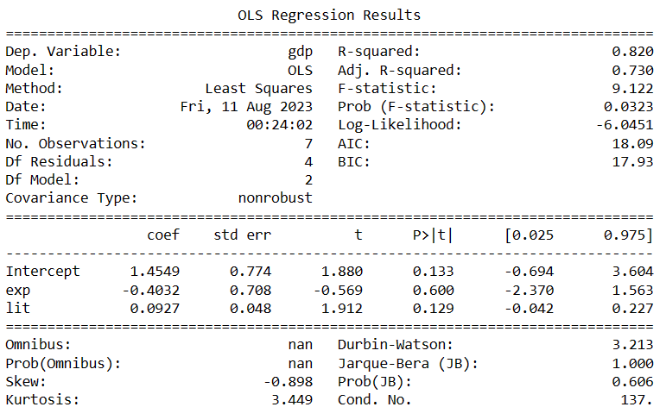

Figure 2: OLS regression

The high R-squared value of 0.82 provides us with the measure of proportion of total variation in the GDP that is explained by the independent variables Literacy rate and Government expenditure on Education. Moreover, the computed R-squared value is statistically significant which is shown by the statistical significance of the computed-F value i.e less than 0.05. Which further shows us the overall significance of the model.

While checking for autocorrelation, heteroskedasticity and multi-collinearity all the test came back negative.

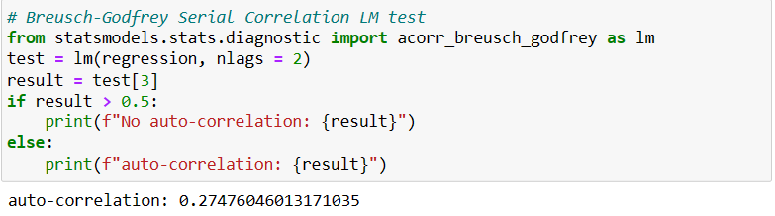

Figure 3: LM Test

*LM test indicated that there is no auto-correlation*

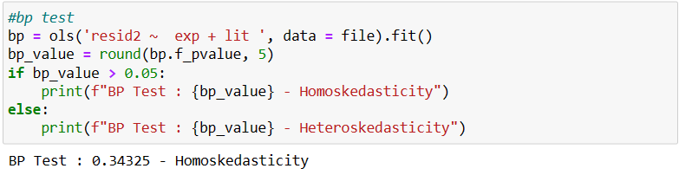

Figure 4: Breusch-Pagan-Godfrey Test

*Breusch-Pagan-Godfrey test for heteroskedasticity shows that there exist no heteroskedasticity*

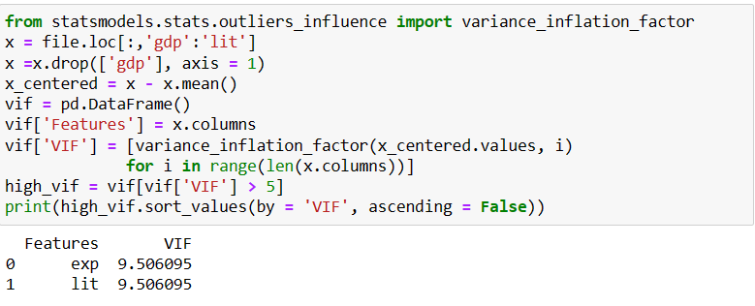

Figure 5: Variance Inflation Factor (VIF)

*VIF values are within the permissible limits*

The regression of the model clearly shows us that there exists a solid causal relationship between the Growth and literacy rate in the context of India.

**Conclusion**:

India has witnessed significant success when it comes to literacy rates. It has increased by nearly six-fold since 1951. Moreover, a strong causal relationship exists in India's context between its growth and literacy rate. Therefore, it becomes essential for the government and educational institutions to find innovative measures to increase the literacy growth rate. However, India currently still faces many structural issues. The way forward would be to decentralize the power over schools to local authorities/bodies and reduce the political power of teacher’s unions which would contribute to building better infrastructure and education system. The suggestion is wider than the above-stated suggestions. We need a more careful examination of the current scenario and develop plans to tap into the potential of our country's human resources. We need to make the necessary reforms in the education sector before India can lose the golden opportunity to change the course of its economic history.

**References**

Desai, V. S. (2012). Importance of literacy in India’s economic growth. *International Journal of Economics and Research*, *3*(2), 112-124.

Rahman, M. S. (2013). Relationship among GDP, per capita GDP, literacy rate and unemployment rate. *British Journal of Arts and Social Sciences*, *14*(2), 169-177.

Shah, N. (2013). Literacy rate in India. *International Journal of Research in all Subjects in Multi Languages*, *1*(7), 12-16.

Cameron, J., & Cameron, S. (2006). The economic benefits of increased literacy. *Background paper prepared for the*.

*GDP growth (annual %) | Data*. (n.d.). World Bank Data. Retrieved August 5, 2023, from <https://data.worldbank.org/indicator/NY.GDP.MKTP.KD.ZG>

*LITERACY AND EDUCATION*. (n.d.). MoSPI. Retrieved August 5, 2023, from <https://www.mospi.gov.in/sites/default/files/reports_and_publication/statistical_publication/social_statistics/WM17Chapter3.pdf>